Name ________________________________ Blood Notes

Period ____ Date ______________________ Forensics

1. Blood is a circulating tissue that consists of 3 types of cells (red, white and platelets) that are suspended in a liquid (plasma)
   1. Red Blood Cells are donut-shaped cells that carry oxygen throughout the body. Includes Hemoglobin.
      1. Hemoglobin is a protein in red blood cells that carries oxygen.
   2. White blood cells are cells that police the body be destroying foreign materials.
   3. Platelets are particles/tissue that aids in clotting of blood.
   4. Antibodies are proteins secreted by white blood cells that attach to antigens.
      1. Antibodies are good to have because they fight disease
   5. Antigens are any foreign substance or cell in the body.
2. Blood can be analyzed in several different ways.

* Blood typing to eliminate suspects.
* DNA from white blood cells
* Blood spatter to recreate a crime scene: direction, angle, origin and velocity

1. Blood has been studied for thousands of years

* 2500 BC Egyptians heart was center of blood supply
* 500 BC Greeks studied arteries and veins
* 1628 blood circulates continuously
* 1795 blood transfusions
* 1874 platelets discovered
* 1900 blood types discovered
* 1922 blood donors
* 1954 AIDS was first detected

1. DNA Profiling History

* Since white blood are a source for DNA since white blood cells have a nucleus.
* 1982 Dr. Alex Jeffreys used DNA to produce the first DNA profile.

1. Blood typing
   1. is a quicker and less expensive to process
   2. is considered to be class evidence because many people have the same blood type
2. Discovery of Blood Types
   1. 1900 Karl Landsteiner
   2. Blood from one person doesn’t always mix feely with blood from another person. If it doesn’t match the blood will clump and the person might die.
   3. Blood seems to have different proteins (A and B) that are found on the surface of red blood cells.
3. Blood Types
   1. A has the A protein
   2. B has the B protein
   3. AB has both the A and B proteins
   4. O has neither the A nor B proteins
4. RH Factor (Rhesus Factor)
   1. Positive - different types of red blood cell protein (85% of people)
   2. Negative – has no RH factor
5. Antigen-Antibody Response
   1. When immune system recognizes a foreign invader it launches an attack of antibodies.
      1. Foreign invaders can be viruses, bacteria or blood of a different type
   2. Agglutination occurs (clumping in the blood) and blood stops flowing, oxygen does not get to cells
6. Additional Blood Proteins and Enzymes can be used to help identify blood:

Ex. M, N, PSM, AK, ADA, ESD….

1. Blood Spatter is a grouping of blood stains
   1. Can help reconstruct the series of events: shooting, stabbing, beating…
   2. The first mention of using blood spatter to solve a crime was in 1894.
2. How Blood Falls
   1. Blood is a thick mixture of blood cells and plasma.
   2. When a person in injured and bleeding gravity acts on blood, pulling it downward
      1. Gravity pulls the drop downward
      2. The droplet gets stretched do to gravity.
      3. Blood is cohesive (attracted to similar substances) and won’t easily split apart.
      4. If any blood does split apart from the drop it is called a satellite.
      5. 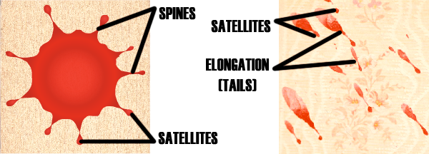
   3. Blood drops on types of surfaces
      1. Blood that drops on smooth surfaces usually have smooth edges.
      2. Blood that drops on porous surfaces have spiked edges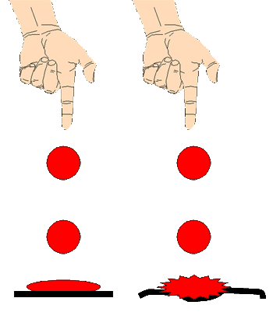

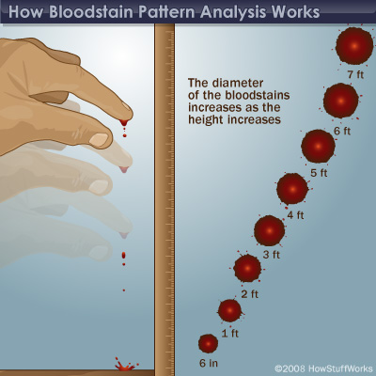

1. Blood Spatter Classification Dr. John Glaister
   * + 1. Passive Fall
          1. Blood Falling due to gravity to the floor at a 90 degree angle will produce circular drops.
       2. Arterial spurts or gushes typically on walls or ceilings are caused by the pumping action of the heart.
       3. Splashes are shaped like exclamation points. The shape and position can locate the position of the victim
       4. Smears are left by a bleeding victim depositing blood as he/she touches or brushed against a wall or furniture.
       5. Trails of blood can be left by a bleeding victim as he/she moves from one location to another. Droplets can be round, spikes, spurts or smears.
       6. Pools of blood form around a victim who is bleeding heavily and remains in one place. If the bleeding victim is moved there may be a trail.

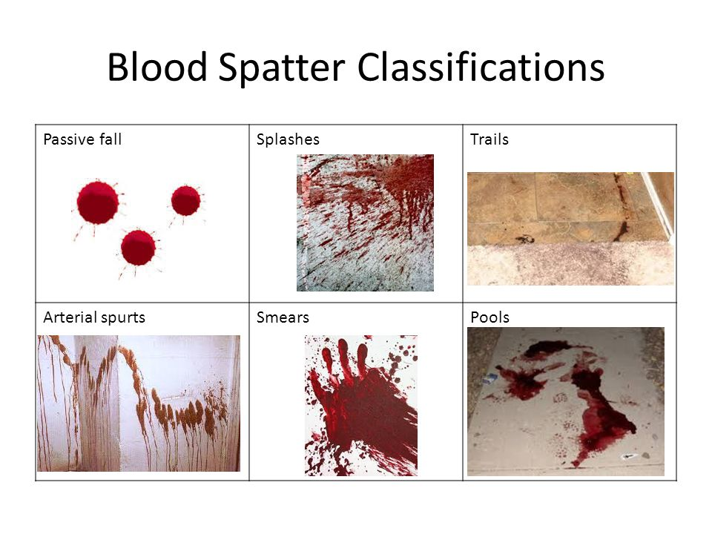

1. Directionality of Blood
   1. The shape of an individual drop of blood provides clues to the direction from where blood originated.
      1. Circular drop of blood indicates that the blood fell straight down at a 90 degree angle.
      2. Elongated drops of blood can determine direction
         1. Cohesion – attraction between like molecules
         2. Adhesion – force between unlike substances
         3. Surface Tension – an elastic characteristic along the outer edge of a liquid caused by cohesion

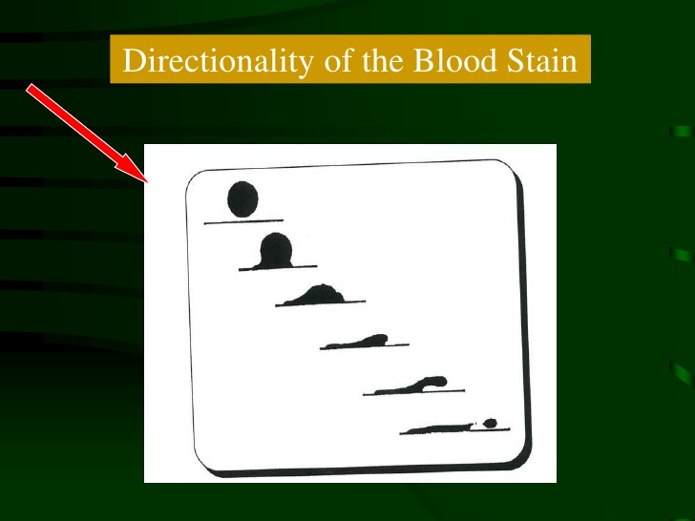

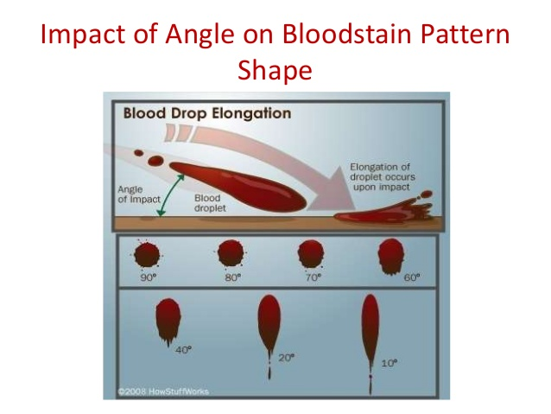

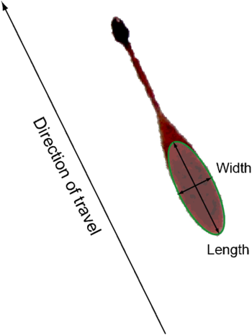

1. Lines of Convergence
   1. The location of the source of blood can be determined if there are at least two drops of blood spatter.

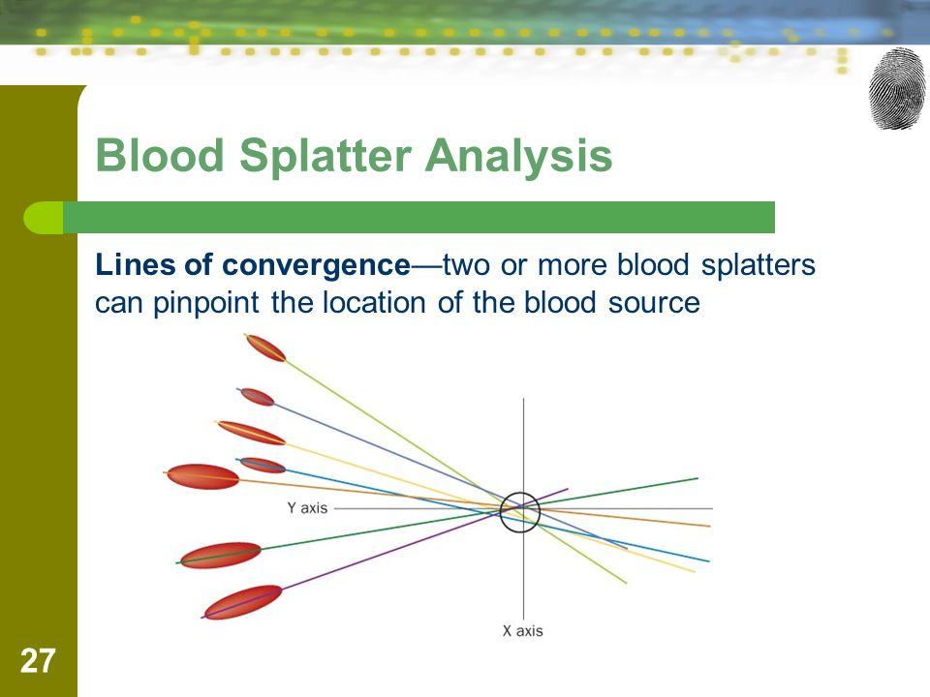

Blood Spatter Types vs Velocity

|  |  |  |  |
| --- | --- | --- | --- |
| Velocity of Impact | Event Occuring | Diameter of blood drop |  |
| Low Velocity  5 ft/second | Blunt Object | 4-6 mm | Image result for low velocity blood spatter |
| Medium Velocity  85 ft/second | Beating, stabbing | 1-4 mm | Image result for medium velocity blood spatter |
| High Velocity  100 ft/second | Gunshot | Less than 1 mm | Image result for high velocity blood spatter |